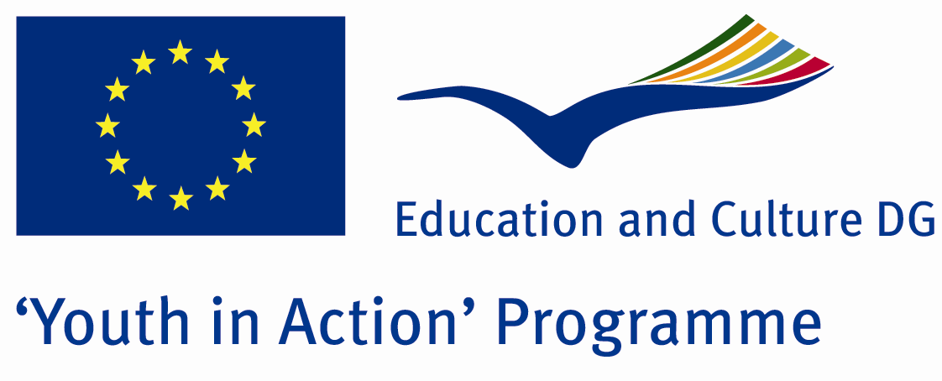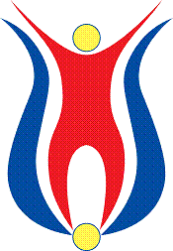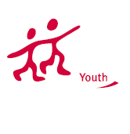

Action 1.1
Project Summary; The period in which humans feel the most freedom is their childhood. In our project, we need volunteers accompany us those childish feelings by playing games and talking on democratic issues and human rights. We invite all the attandants in the activities on education, democracy and human rights on the streets of our city.

Project Title; Teaching Democracy with Games
Date and Venue ; 08-15 2013 April Turkey
Place: KASTAMONU.

Target Group ; Municipalities, City Councils and Non-Governmental organizations,
youth groups,culture and art groups,e.t.c

Participants ; 5 people from each country (over 18 -25 ). Totally 7 countries.

Conditions ; Accommodation, board and programme costs will be financed through European Commission Youth in Action Programme . Travel costs will be reimbursed in 70% (APEX Tarrifs). Organizations from all 27 EU member countries plus Liechtenstein , Norway and Iceland are eligible to take part.

Working language: English

Organisator group: Group Game Teachers

How to apply: If you are interested, please send your Part III forms to
by e-mail please (in word file). Scan Part3 format is enough for application.(Fulfilled Part III which you can find in the attachment, of course signed and stamped) ..

Contact e-mail: groupsymrnes@gmail.com
Group e-mail: gameteacherss@gmail.com

Deadline to apply:20.09.2012

